**CHEETAH OPTIMIZATION ALGORITHM: ECONOMIC LOAD DISPATCH PROBLEM**

**Sakshi Kamble, Pranjali Nanaware, Arundhati Wandhekar**

Department of Information Technology, Walchand College of Engineering, Sangli, India

[kamblesakshi1210@gmail.com](mailto:kamblesakshi1210@gmail.com) , [nanawarepranjali@gmail.com](mailto:nanawarepranjali@gmail.com) , [arundhatiwandhekar25@gmail.com](mailto:arundhatiwandhekar25@gmail.com)

**Abstract**

The ELD problem is a significant optimization challenge in power systems, aiming to minimize operating costs while meeting the load demand. This research paper proposes the utilization of the Cheetah Optimization Algorithm (COA) to efficiently solve the ELD problem. Inspired by the hunting behaviour of cheetahs, COA combines exploration and exploitation strategies to search for the optimal power generation schedule.

The ELD problem involves determining thepower output of each generator unit while satisfying various constraints, including power balance, ramp rate limits, and generator capacity limits. COA is applied to this problem by formulating it as a constrained optimization task with the objective of minimizing the total generation cost.

To evaluate COA's performance on the ELD problem, comprehensive experiments are conducted on standard test systems, comparing its results with other existing optimization methods. The simulation results demonstrate COA's effectiveness in finding near-optimal solutions with reduced computation time. COA successfully optimizes the power generation schedule, achieving cost savings and meeting the load demand while satisfying operational constraints.

Furthermore, this research analyses COA's convergence behaviour and performs sensitivity analysis to examine its robustness and adaptability

In the Cheetah Optimization Algorithm proves to be a promising approach for solving the ELD problem. Its ability to balance exploration and exploitation, combined with its efficient search capabilities, makes it a valuable tool for power system optimization. This research provides valuable insights and opens avenues for further investigations and improvements in the utilization of nature-inspired algorithms for power system optimization tasks.

**Keywords**

Cheetah Optimization Algorithm, metaheuristic optimization algorithm, ELD Problem.

**1. INTRODUCTION**

The optimization of power system operation is of paramount importance to ensure efficient and reliable electricity supply. The Economic Load Dispatch (ELD) problem, a critical optimization challenge in power systems, involves determining the optimal power generation schedule for each generator unit while satisfying various operational constraints. The primary objective is to minimize the total operating cost while meeting the load demand.

Traditionally, the ELD problem has been addressed using conventional optimization techniques such as linear programming, gradient-based methods, and evolutionary algorithms. However, these methods often suffer from issues such as slow convergence, premature convergence to local optima, and difficulty in handling complex constraints.

To overcome these limitations, this research paper introduces the Cheetah Optimization Algorithm (COA) as a nature-inspired metaheuristic algorithm for solving the ELD problem. COA draws inspiration from the hunting behaviour of cheetahs, known for their exceptional speed and agility. By mimicking the strategies employed by cheetahs during hunting, COA combines exploration and exploitation to effectively search for optimal solutions.

The cheetah's hunting behaviour involves a sequence of actions, including searching for prey, pursuing the prey, and encircling it. Similarly, COA incorporates these steps into its optimization process. During the prey search phase, the algorithm explores the search space to diversify the solutions. In the prey pursuit phase, COA adjusts the positions of solutions towards the best positions found. Finally, in the prey encircling phase, the algorithm intensifies the search and converges towards the optimal solution.

The motivation behind utilizing the Cheetah Optimization Algorithm lies in its potential to address the challenges faced by traditional optimization methods in solving the ELD problem. COA offers a balance between exploration and exploitation, allowing for efficient search in the solution space, including complex constraints.

In this research paper, we aim to evaluate the performance of COA in solving the ELD problem and compare it with existing optimization methods. We conduct comprehensive experiments on standard test systems, considering various operational constraints and objective functions. Through these experiments, we analyze COA's effectiveness in finding near-optimal solutions while ensuring reliable power system operation.

**2. CHEETAH OPTIMIZATION ALGORITHM**

1. Define the problem data, dimension(D),and the initial population size(n)
2. Generate the initial population of cheetahs Xj(i=1,2,.....n) and evaluate the fitness of each cheetah
3. Initialize the populations home, leader and prey solutions
4. t <- 0
5. it <- 1
6. MaxIt <- desired maximum number of iterations
7. T <- 60 x [D/10]
8. while it <= Maxlt do
9. Select m(2 <= m <= n) members of cheetahs randomly
10. for each member i E m do
11. Define the neighbor agent of member i
12. for each arbitrary arrangement j {1,2,....D} do
13. Calculate r^, r, a, b, and H
14. r2,r3 <- random numbers are chosen uniformly from 0 to 1
15. if r2 <= r3 then
16. r4 <- a random number is chosen uniformly from 0 to 3
17. if H >= r4 then
18. Calculate the new position of member i in arrangement j using Equation (3) // Attack
19. else
20. Calculate the new position of member i in arrangement j using Equation (1) // Search
21. end
22. else
23. Calculate the new position of member i in arrangement j using Equation (2) // Sit-and-wait
24. end
25. end
26. Update the solutions of member i and the leader
27. end
28. t <- t + 1
29. if t > r and x T and the leader position doesn’t changes for a time, then //Leave the prey and go back home
30. Implement the leave the prey and go back home strategy and change the leader position
31. Substitute the position of member i by prey position
32. t <- 0
33. end
34. it <- it + 1
35. Update the prey (global best) solution
36. end

When a cheetah is actively surveying or observing its environment, there is a possibility of detecting potential prey. Once the cheetah becomes aware of the prey's presence, it can consider its next move. Upon sighting the prey, the cheetah may choose to remain stationary and wait for the prey to come closer before initiating an attack. The attack phase involves two crucial steps: rushing and capturing. However, there are instances where the cheetah may abandon the hunt due to various factors, such as limited energy or the prey's rapid escape. In such cases, the cheetah may return home to rest and prepare for a new hunting attempt. The cheetah intelligently selects one of these strategies based on factors like prey assessment, its own condition, the area, and the distance to the prey. The COA algorithm leverages these hunting strategies during iterations to optimize the search process.

Cheetah used following strategies for hunting.

1. Searching: Cheetahs actively scan or search their territories or the surrounding area to locate prey. This corresponds to exploring the search space in the algorithm.

Xt+1i,j = Xti,j + r^-1i,j * αti,j

1. Sitting-and-waiting: If the prey is detected but the conditions are not favorable, cheetahs may choose to patiently sit and waiting for the prey to approach or for the situation to improve.

Xt+1i,j = Xti,j

1. Attacking: This strategy involves two key steps. First, when the cheetah decides to attack, it rapidly rushes toward the prey at maximum speed. Second, employing its speed and agility, the cheetah captures the prey by closing in on it.

Xt+1i,j = Xt**β,j + r^i,j . βti,j**

1. Returning home: This strategy is executed in two scenarios. Firstly, if the cheetah failed to hunt the prey, it may change its position or return to its territory. Secondly, if there have been no successful hunting actions within a certain time interval, the cheetah may move to the last known prey location and resume searching in that vicinity.

**3. ECONOMIC LOAD DISPATCH PROBLEM**

The ELD is a significant optimization challenge encountered in power systems engineering. It involves determining the most optimal allocation of power output among multiple generators in a power system, aiming to satisfy the load demand while minimizing the overall generation cost.

The primary objective of ELD is to distribute the load demand among available generators in a manner that minimizes the total operating cost, encompassing factors such as fuel costs and operational constraints. This optimization problem takes into consideration various aspects, including generator characteristics, transmission line losses, and system stability limitations.

When addressing the ELD, both the real power (active power) and reactive power of the generators are considered, while adhering to specified limits and operational constraints. The ultimate goal is to identify the optimal set points for the generators, ensuring the lowest possible operating cost while meeting the load demand.

To tackle the ELD, diverse approaches such as mathematical programming methods, evolutionary algorithms, and heuristics are employed. These techniques aim to explore the solution space, considering the various constraints, in order to identify the most cost-effective dispatch strategy.

The ELD plays a vital role in power system operations as it directly impacts the cost associated with electricity generation and the stability of the system. Effective solutions to this problem contribute to efficient utilization of resources, reduced operational costs, and enhanced reliability within power systems.

**3.1 ELD FORMULATION**

Consider an electrical groups park with n generating units. The total fuel cost for power generation to be minimized is the sum of contributions of each generating units

Min F(X) = $\sum_{i=1}^{i=n}{Fi(Pi)}$

Fi is the fuel cost function for the generation unit i (in $/h) and Pi (in MW) is the real power output for this unit.

The fuel cost of each generation unit i is represented by a quadratic equation.

$$Fi(Pi) = aiP^{2}i +biPi+ci$$

ai, bi and ci are the fuel cost coefficients of the unit i

min(Pi) and max(Pi) are the minimum and maximum generation limits of unit i.

${ P}_{i}^{min}$ <= $P_{i}$ <= $P_{i}^{max}$

The total generated power by the units must be equal to the sum of total load demand and total real power loss in the transmission lines, as follows

$$\sum_{i=1}^{i=n}{Pi-Pd-Pl}=0$$

Pd is the total system real power demand (in MW)

Pl is the overall system real power losses (in MW)

Table 4.1. Input values for 6 generators

|  |  |  |  |  |  |
| --- | --- | --- | --- | --- | --- |
| Unit | ai | bi | ci | Pmin | Pmax |
| 1 | 0.007 | 7 | 240 | 100 | 500 |
| 2 | 0.0095 | 10 | 200 | 50 | 200 |
| 3 | 0.009 | 8.5 | 220 | 80 | 300 |
| 4 | 0.009 | 11 | 200 | 50 | 150 |
| 5 | 0.008 | 10.5 | 220 | 50 | 200 |
| 6 | 0.0075 | 12 | 120 | 50 | 120 |

Table 4.2 output of ELD problem by using COA algorithm

|  |  |  |
| --- | --- | --- |
| Iteration | Best Solution | Total Cost |
| 500 | [100.25, 71.06, 90.84, 58.44, 71.11, 50.74] | 5666.214 |

|  |  |  |  |  |  |  |  |
| --- | --- | --- | --- | --- | --- | --- | --- |
| **MW** | **TECHNIQUE** | **POWER GENERATED BY EACH GENERATORS (MW)** | | | | | |
| **G1** | **G2** | **G3** | **G4** | **G5** | **G6** |
| 500 | BOA | 225.54 | 50.00 | 80.00 | 50.000 | 50.000 | 50.000 |
| GA | 213.62 | 55.66 | 80.35 | 50.232 | 55.036 | 50.743 |
| PSO | 221.19 | 50.00 | 84.391 | 50.000 | 50.000 | 50.000 |
|  | COA | 161.469 | 55.367 | 91.120 | 56.657 | 69.314 | 63.100 |

Table 4.3 comparison of output with other algorithms

Fig 1 Graphical representation of 30 readings for 500 MW

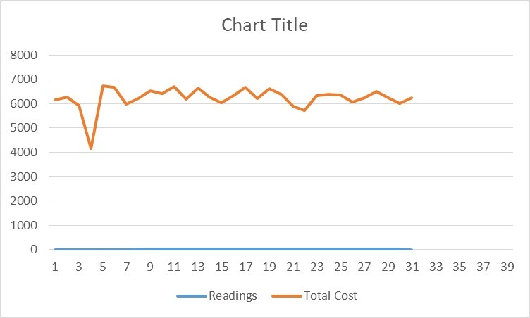

Fig 2 Graphical representation of 30 readings for 600 MW

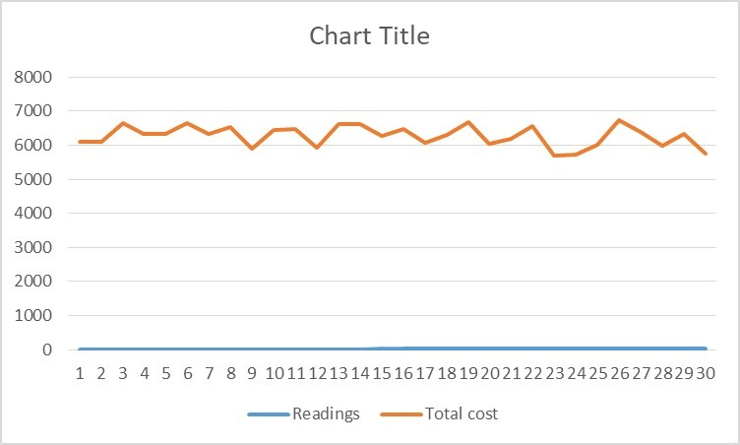

Fig 3 Graphical representation of 30 readings for 700 MW

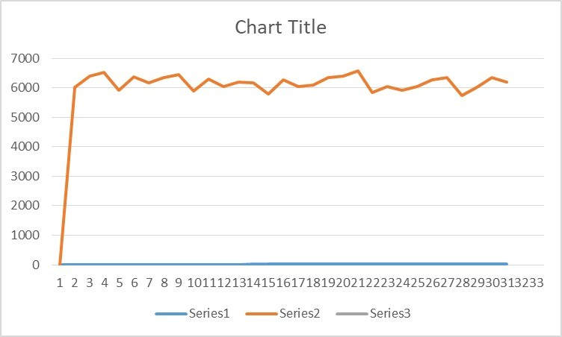

**4. CONCLUSION**

By applying the COA algorithm to the ELD problem, researchers and engineers can effectively optimize power generation dispatch, considering factors such as generator constraints, transmission line losses, and demand variations. The COA algorithm's ability to explore the search space and converge towards optimal or near-optimal solutions makes it a suitable choice for solving the ELD problem.

**5. ACKNOWLEDGEMENT**

We would like to express our deepest gratitude to all those who have contributed to the successful completion of this research paper. In particular, we would like to extend our sincere appreciation to the developers and contributors of the Cheetah Optimization Algorithm, whose innovative and efficient approach has greatly influenced our study.

The Cheetah Optimization Algorithm has proven to be a valuable tool in tackling complex optimization problems, providing inspiration and guidance throughout our research journey. Its remarkable ability to mimic the hunting behavior of cheetahs and its application in various domains have greatly enhanced our understanding of optimization techniques.

**REFERENCES**

1. Sergeyev, Y. D., Kvasov, D. E. & Mukhametzhanov, M. S. On the efciency of nature-inspired metaheuristics in expensive global optimization with limited budget. Sci. Rep. 8, 1–9 (2018).
2. Luo, X., Liu, H., Gou, G., Xia, Y. & Zhu, Q. A parallel matrix factorization based recommender by alternating stochastic gradient decent. Eng. Appl. Artif. Intell. 25, 1403–1412 (2012)..
3. Lu, T. & Liu, S.-T. Fuzzy nonlinear programming approach to the evaluation of manufacturing processes. Eng. Appl. Artif. Intell. 72, 183–189 (2018).
4. Koc, I., Atay, Y. & Babaoglu, I. Discrete tree seed algorithm for urban land readjustment. Eng. Appl. Artif. Intell. 112, 104783 (2022). M. Mahdavi, M. Fesanghary, E. Damangir. “An improved harmony search algorithm for solving optimization problems.”. Applied Mathematics and Computation, vol.188, pp. 1567–1579, 2007
5. Spall, J. C. Introduction to Stochastic Search and Optimization: Estimation, Simulation, and Control Vol. 65 (Wiley, 2005).
6. Cruz, Y. J. et al. Ensemble of convolutional neural networks based on an evolutionary algorithm applied to an industrial welding process. Comput. Ind. 133, 103530 (2021).
7. Haber, R. E., Beruvides, G., Quiza, R. & Hernandez, A. A simple multi-objective optimization based on the cross-entropy method. IEEE Access 5, 22272–22281 (2017).
8. Alba, E. & Dorronsoro, B. Te exploration/exploitation tradeof in dynamic cellular genetic algorithms. IEEE Trans. Evol. Comput. 9, 126–142 (2005).
9. Wang, J.-S. & Li, S.-X. An improved grey wolf optimizer based on diferential evolution and elimination mechanism. Sci. Rep. 9, 1–21 (2019).
10. Lozano, M. & García-Martínez, C. Hybrid metaheuristics with evolutionary algorithms specializing in intensifcation and diversifcation: overview and progress report. Comput. Oper. Res. 37, 481–497 (2010)
11. Economic Load Dispatch Problem Using Butterfly Optimization Algorithm (European Journal of Molecular & Clinical Medicine ISSN 2515-8260 Volume 7, Issue 4, 2020)
12. Medium Blog : <https://medium.com/@veys101/solving-economic-load-dispatch-by-using-gray-wolf-optimizer-2c8b48ec3bd5>
13. Cheetah chase algorithm (CCA): a nature-inspired metaheuristic algorithm(International Journal of Engineering & Technology, 7 (3) (2018) 1804-1811)